**Crypto Fear & Greed Index**

The Fear & Greed Index is an index developed by CNN Business to measure investor sentiment. Originally, it indicates how emotions influence the way investors pay for stocks, using seven indicators, between then the market volatility.

For the Crypto Fear & Greed Index, it was developed by Alternative to create a sentiment index for Bitcoin and other cryptocurrencies, based on the original one. It uses six inputs:

1. **Volatility (25%):** Measuring the current volatility and max drawdowns of bitcoin and compare it with the corresponding average values of the last 30 days and 90 days. The developers argue that an unusual rise in volatility is a sign of a fearful market.
2. **Market Momentum/Volume (25%):** Again, in comparison with the last 30/90-day average values, the current volume and market momentum are measured and put those two values together. Generally, when there are high buying volumes in a positive market on a daily basis, the market acts overly greedy / too bullish.
3. **Social Media (15%):** Based on a Twitter analysis, supported by the paper *Cryptocurrency Price Prediction Using Tweet Volumes and Sentiment Analysis* by Abraham et al., posts on various hashtags for each coin are counted, and checked how fast and how many interactions they receive in certain time frames. An unusual high interaction rate results in a grown public interest in the coin and, in the eyes of the authors, corresponds to a greedy market behavior.
4. **Surveys (15%):** Conducting weekly crypto polls, in strawpoll.com, and asking people how they see the market, one can have a picture of the sentiment of a group of crypto investors.
5. **Dominance (10%):** The dominance of a coin resembles the market cap share of the whole crypto market. Especially for Bitcoin, theoretically a rise in Bitcoin dominance is caused by a fear of (and thus a reduction of) too speculative alt-coin investments, since Bitcoin is becoming more the safe haven of crypto. On the other side, when Bitcoin dominance shrinks, people are getting greedier by investing in riskier alt-coins.
6. **Trends (10%):** Pulling Google Trends data for various Bitcoin related search queries and crunch those numbers, especially the change of search volumes as well as recommended other currently popular searches, is possible to infer the sign of fear or greed in the market.

The Crypto Fear and Greed Index is a 100-point scale. A lower number implies a more fearful bear market, while a higher number indicates a greedier, bull market climate, by scores:

* 0-24: represents extreme fear
* 25-44: shows a more modest level of fear
* 45-55: expresses a neutral market
* 56-75: means investors are feeling greedy
* 76-100: shows extreme greed among investors

The data used is produced and maintained by the administrators of <https://alternative.me/crypto/fear-and-greed-index/>, using their API (e.g., GET <https://api.alternative.me/fng/?limit=0&format=csv>).

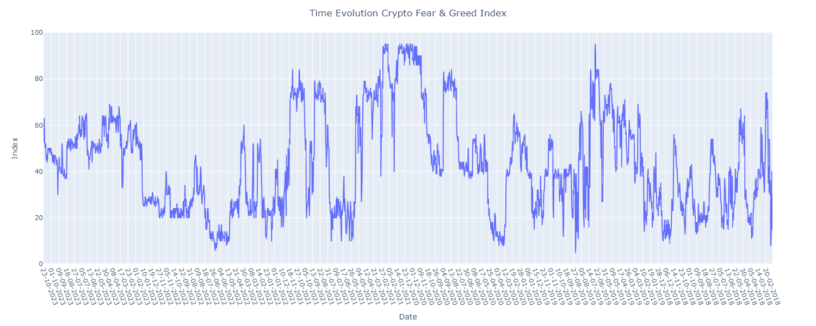**Index Evolution Graph:**